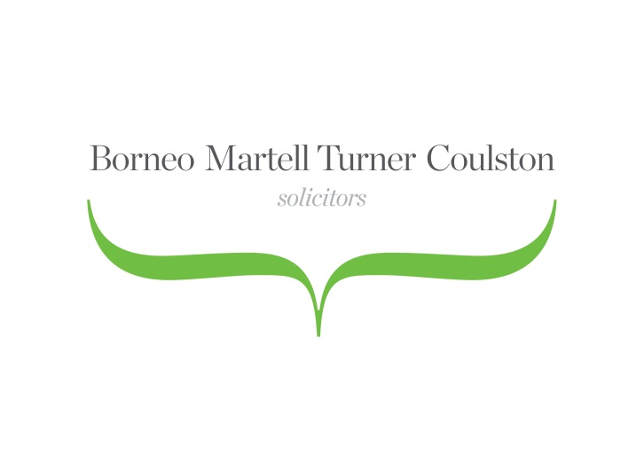

Top 10 Tips – Guide to Selling a Property

- Estate Agent
Decide on how you want to market your property or instruct an estate agent.
- EPC
Instruct a qualified person to prepare an Energy Performance Certificate (EPC) on your behalf. This is a document that contains a rating for the energy performance of the property and makes recommendations for improving it.
- Solicitor
Instruct a solicitor to do the following;
- Title Deeds
The Solicitor will obtain your deeds and other documents and prepare the Contract pack to send to your buyer’s solicitor.
- Redeeming your mortgage
A redemption statement will be requested from your mortgage lender. If you have a mortgage on the property, your Solicitor will liaise with your lender and pay off your mortgage on completion.
- Reply to enquiries
Your Buyer’s Solicitor will usually raise enquiries and your Solicitor will deal with these as quickly as possible.
- Additional information
The purchaser may require you to provide additional information such as copies of insurance policies, planning permission and building regulation approvals.
- Contract and Transfer deed
Your Solicitor will arrange for you to sign the Contract and Transfer deed and proceed to Exchange Contracts on your behalf.
- Exchange of contracts
With your authority your Solicitor will exchange contracts is when the sale becomes legally binding and a completion date will have been agreed.
- Completion
The day of completion, is the day that you will vacate the property, your Solicitor will redeem your mortgage and the keys are handed over to the new owners. Any other charges on the property will also be paid off, any estate agent fees will be paid and your proceeds paid to you or to your onward purchase.
Please call 01604 622101 and ask to speak to one of our conveyancing team if you have any queries.

