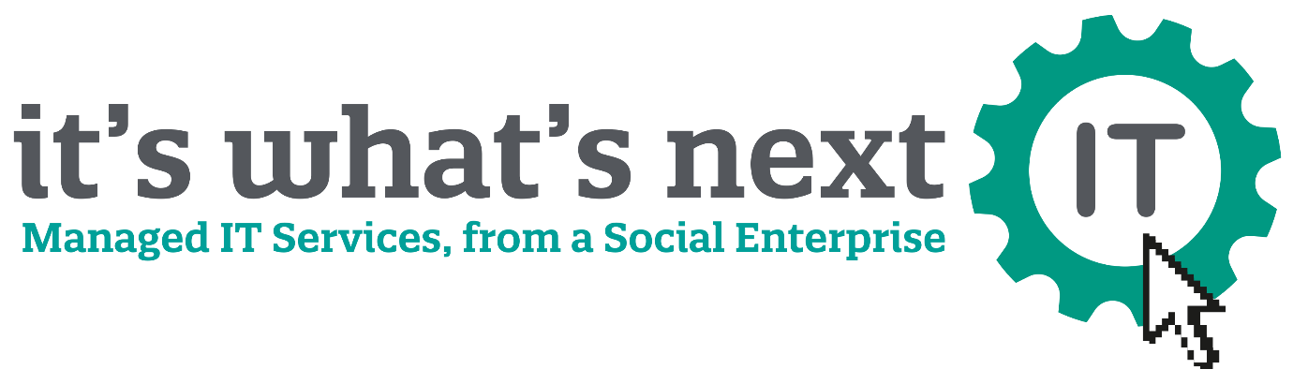

Our Top Tips for SME’s:
- Keep your software up to date
- Practice good password management
- Beware of suspicious emails and calls
- Accept that you could be a target – and prevent!
- Be careful what you click
- Never leave your devices unattended
- Use your mobile devices securely
- Safeguard your protected data
- Install anti-virus/malware protection
- Back up your data.

Our technical team work around the clock to take care of this for you, ensuring your IT fits your business needs, leaving you time to concentrate on growth.
For your free quote, or any enquires please get in touch with the details provided below.
www.iwn-it.com
zoeh@iwn-it.com
01908 410883 / 07934 305706

